AI-Based Classification of Medicinal Plants Growing in Weed-Infested Areas in Bangladesh

# Abstract

This study develops an AI system to classify 34 medicinal plant species from Bangladesh’s weed-infested areas, tackling the difficulty of manual identification in complex environments. Using a novel dataset of 17,050 RGB images from field and public sources, a custom lightweight CNN named FloraNet was trained for 300 epochs, combining image and morphometric features to boost accuracy. FloraNet achieves 98% accuracy, outperforming pretrained models like DenseNet121 and VGG16, while maintaining a compact size of 342 KB—99.5% smaller than EfficientNetB4. Architectural innovations such as pruning and depthwise separable convolutions enable fast, accurate inference. This work supports biodiversity research, ethnobotany, and rural healthcare by enabling real-time plant identification on mobile and edge devices in resource-limited settings.

*Keywords:* Medicinal plants, Deep learning, Convolutional Neural Network, FloraNet, Weed-infested areas of Bangladesh.

# Introduction

Medicinal plants are crucial for healthcare in Bangladesh, where 70–80% of rural people depend on traditional remedies. With over 700 species used in Ayurvedic, Unani, and folk medicine, these plants provide anti-inflammatory, antimicrobial, and antioxidant benefits. However, conservation and accurate identification remain difficult, especially in weed-infested rural and peri-urban areas that host species like Centella asiatica, Kalanchoe pinnata, and Mentha arvensis. Dense vegetation, poor lighting, and similarities with non-medicinal plants complicate manual identification, which is further hindered by limited botanical expertise. Automated, scalable identification is needed. While CNN-based deep learning shows promise, its real-world use is restricted by a lack of diverse ecological datasets. This study presents an AI framework using a novel dataset of 17,050 field and public-source images covering 34 species—including Aloe barbadensis, Moringa oleifera, and Pandanus odorifer—aiming for accurate, real-time classification in complex environments to support biodiversity research and healthcare in rural Bangladesh.

The major contributions of this project are detailed as follows:

* **Development of FloraNet, a Lightweight CNN Model**: Developed a custom CNN, FloraNet, with a compact size of 342.04 KB—a 99.5% reduction compared to EfficientNetB4—while matching or outperforming larger models like DenseNet121 and VGG16.
* **Real-World Applicability**: Optimized for real-time use on mobile apps and IoT devices, making it suitable for rural healthcare and biodiversity monitoring.
* **Ecologically Diverse Dataset**: Compiled 17,050 field images across diverse natural conditions, offering a robust benchmark for plant identification in weed-infested areas.

# Literature Review

Image-based medicinal plant classification has progressed with convolutional and hybrid deep learning models, emphasizing dataset diversity, robustness, and mobile deployment. Akter et al. (2020)⁵ used a 3-layer CNN on 10 Bangladeshi species, achieving 71.3% accuracy and introducing a mobile app prototype. Azadnia et al. (2024)⁶ reached 99.56% accuracy with ResNeSt101+SCAM on a well-balanced dataset, though limited to three plant categories. Dileep et al. (2019)⁷ used a CNN-SVM hybrid on 40 South Indian plants (96.76% accuracy), but its regional scope limits generalization. Aakif & Khan (2015)⁸ applied ANN on 14 fruit plant classes (96% accuracy), though with a small, imbalanced dataset. Gopal et al. (2013)⁹ classified 10 plants with 92% accuracy from only 100 images, limiting scalability. Muneer et al. (2020)¹⁰ created Snap Herb, a mobile app for 20 herbs, achieving 93% accuracy with DNN despite minimal data. In Bangladesh, Uddin et al. (2023)¹¹ used a 5,000-image dataset across 10 classes; DenseNet201 performed best (85% accuracy), while ResNet50 underperformed. Islam et al. (2023)¹² introduced the BDMediLeaves dataset (2,029 images), achieving 90.09% accuracy and a 96.10% F1-score with DenseNet201-FCN. Habiba et al. (2019)¹³ used 1,054 Barisal images to reach 96.11% accuracy with SVM, showing classical methods can still be competitive with curated, regional datasets.

*Table 1. Literature Overview*

|  |  |  |  |  |  |  |  |
| --- | --- | --- | --- | --- | --- | --- | --- |
| Au | Cl | Im | Lc | Bm | Ac | Bl | Cn |
| **Akter et al.5** | 10 | – | BD | 3-layer CNN | 71.30% | No | Classified single & compound leaf |
| **Azadnia et al.6** | 3 | – | Iran | Tree-CA | 99.63% | Yes | Distinguishes poison/medicinal |
| **Dileep et al.7** | 40 | 2400 | India | CNN + SVM | 96.76% | Yes | SVM-based decision |
| **Aakif & Khan8** | 14 | 817 | Pakistan | Custom 3-stage pipeline | 96% | No | 3-step pipeline |
| **Gopal et al.9** | 10 | 100 | India | Custom Algo. | 92% | Yes | Early algorithm |
| **Muneer et al.10** | 20 | 1000 | Malaysia | DLNN | 93% | Yes | Real-time mobile classifier |
| **Uddin et al.11** | 10 | 5000 | BD | DenseNet201 | 85% | Yes | Public dataset |
| **Islam et al.12** | 10 | 2029 | BD | DenseNet201-FCN | 80.7% | No | Collected from 5 BD locations |
| **Habiba et al.13** | 10 | 1054 | BD | SVM | 96.10% | No | New dataset |
| Our Proposed Model | 34 | 17050 | BD | FloraNet (custom CNN) | 98% | Yes | Large novel dataset.  A very Lightweight (342 KB) model that is good for mobile or other device |

**Note**: **Au = Author, Cl = Classes, Im=Image Count Lc=Location, Bm=Best Model, Ac=Accuracy, Bl=Balanced Dataset, Cn=Contribution**

# Dataset Description

This study presents a novel dataset for classifying medicinal plants in Bangladesh’s weed-infested areas, featuring 17,050 high-resolution RGB images across 34 therapeutic species. Designed to reflect real-world ecological complexity—including dense vegetation, uneven lighting, and competing flora—the dataset addresses a major gap in ethnobotanical and AI research. Unlike controlled image datasets, it captures challenges like shadowing, soil variation, and morphological similarity, enhancing the robustness of AI models for field use. It offers a valuable resource for improving plant identification in rural, resource-limited areas, supporting biodiversity conservation, ethnobotanical studies, and AI-powered healthcare solutions. Each class is labeled with Bangla, English, and scientific names, with nearly uniform distribution (~500 images/class), except Moringa oleifera (520) and Aloe barbadensis (530), ensuring minimal class imbalance.

*Table 2. Class Table Overview*

|  |  |  |  |  |
| --- | --- | --- | --- | --- |
| **SL** | **Bangla Name** | **English Name** | **Scientific Name** | **Image Count** |
| 1 | Thankuni | Asiatic Pennywort | Centella asiatica | 500 |
| 2 | Pathorkuchi | Life Plant | Kalanchoe pinnata | 500 |
| 3 | Apang | Prickly Chaff Flower | Achyranthes aspera | 500 |
| 4 | Kalomegh | Green Chiretta | Andrographis paniculata | 500 |
| 5 | Kaluchitra | Black Nightshade | Solanum nigrum | 500 |
| 6 | Ayapan | Ayapana | Eupatorium triplinerve | 500 |
| 7 | Akondo | Crown Flower | Calotropis gigantea | 500 |
| 8 | Bamonhati | Devil's Cotton | Abroma augusta | 500 |
| 9 | Kalodhutra | Black Datura | Datura metel | 500 |
| 10 | Tarulata | Sweet Potato Vine | Ipomoea batatas | 500 |
| 11 | Punarnava | Spreading Hogweed | Boerhavia diffusa | 500 |
| 12 | Agnishikha | Flame of the Forest | Butea monosperma | 500 |
| 13 | Tulsi | Holy Basil | Ocimum sanctum | 500 |
| 14 | Ramtulshi | Tree Basil | Ocimum gratissimum | 500 |
| 15 | Basok | Malabar Nut | Justicia adhatoda | 500 |
| 16 | Neem | Neem | Azadirachta indica | 500 |
| 17 | Pudina | Mint | Mentha arvensis | 500 |
| 18 | Joba | Hibiscus | Hibiscus rosa-sinensis | 500 |
| 19 | Sojina | Drumstick Tree | Moringa oleifera | 520 |
| 20 | Gandha | Fragrant Screw Pine | Pandanus odorifer | 500 |
| 21 | Shotomuli | Shatavari | Asparagus racemosus | 500 |
| 22 | Sarpagandha | Indian Snakeroot | Rauvolfia serpentina | 500 |
| 23 | Anantamul | Indian Sarsaparilla | Hemidesmus indicus | 500 |
| 24 | Chapalish | Chaplash | Artocarpus chaplasha | 500 |
| 25 | Amloki | Indian Gooseberry | Phyllanthus emblica | 500 |
| 26 | Haritoki | Chebulic Myrobalan | Terminalia chebula | 500 |
| 27 | Bohera | Beleric Myrobalan | Terminalia bellirica | 500 |
| 28 | Oshwagandha | Ashwagandha | Withania somnifera | 500 |
| 29 | Devil's Backbone | Mother of Thousands | Kalanchoe daigremontiana | 500 |
| 30 | Lemongrass | Lemongrass | Cymbopogon citratus | 500 |
| 31 | Aloe Vera | Aloe Vera | Aloe barbadensis | 530 |
| 32 | Nayontara | Madagascar Periwinkle | Catharanthus roseus | 500 |
| 33 | Gainura | Longevity Spinach | Gynura procumbens | 500 |
| 34 | Betal | Betel Leaf | Piper betle | 500 |

Note: Some species are taxonomically or visually similar, such as Ocimum sanctum and Ocimum gratissimum, or Kalanchoe pinnata and Kalanchoe daigremontiana, presenting classification challenges.

The dataset presents several challenges that are relevant for real-world classification tasks. Some plant species exhibit visually similar leaf structures, such as *Ocimum sanctum* and *Ocimum gratissimum*, or *Kalanchoe pinnata* and *Kalanchoe daigremontiana*, which can make accurate species differentiation challenging for models. Additionally, natural variability in leaf orientation, lighting and background clutter reflect real deployment scenarios, strengthening the model’s generalization capacity.

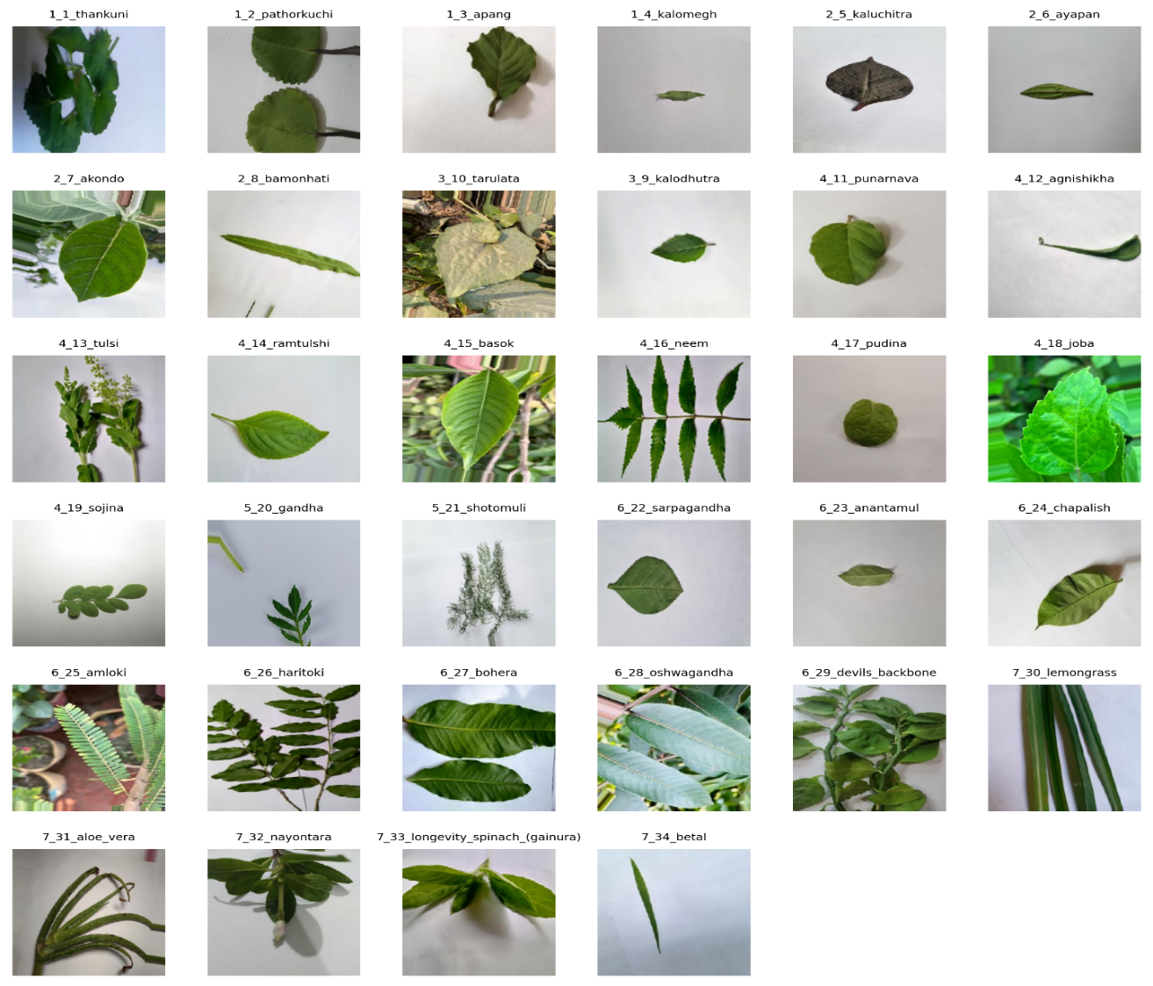

*Fig. 1: 34 Medicinal Plants images*

# Methodology

## Overview

The methodology for developing a custom FloraNet model15, a Convolutional Neural Network (CNN)15 for classifying 34 medicinal plant species, is outlined as follows: Data Collection involves acquiring images from field observations and public repositories. Dataset Re-Organization16 splits the dataset into 70% training, 15% validation and 15% testing. Dataset Organization consolidates the data. Pre-Processing resizes images to 300x300 pixels, converts them to RGB JPG format and applies data augmentation17 (e.g., rotation, flipping). Model Development employs the FloraNet architecture15, compiled with a loss function (e.g., categorical cross-entropy)16, an optimizer (e.g., Adam)16 and callbacks16, trained over 300 epochs16. Evaluation & Deployment tests the model on unseen data, followed by performance evaluation using metrics like accuracy17, precision17, recall17 and F1-score17.

*Fig. 2: Workflow for CNN-Based Medicinal Plant Classification*

## Dataset Collection

The dataset was compiled using field-based image collection and public online repositories, focusing on medicinal plants common in Bangladesh’s weed-infested habitats. These environments, often overlooked, contain many therapeutic species underrepresented in existing datasets. To capture real field conditions, images include diverse backgrounds, lighting, and natural obstructions. Field images of four species—Pandanus odorifer, Moringa oleifera, Mentha arvensis, and Aloe barbadensis—were taken across rural Bangladesh using a Samsung Galaxy A52 smartphone with a 64 MP lens under daylight. Each class has about 500–530 high-resolution images, adding natural variability for model training. The remaining 30 classes were sourced from three online datasets: two from Mendeley Data Repository (6 and 14 species) and one from Kaggle (10 species). Imbalanced classes were augmented (rotation, flipping, color adjustments) to roughly 500 images per class. All images were resized to 300×300 pixels in RGB JPEG format. While repository images often have plain backgrounds, field images retain natural contexts, offering realistic training data. Labels were folder-assigned and verified with an ethnobotanist. The full dataset includes 17,050 images across 34 classes, split 70% training, 15% validation, and 15% testing.

## Model development

To solve the problem of medicinal plant classification in weed-infested areas, we propose a hybrid deep learning model named FloraNet, which combines image-based visual features and structured physical characteristics of the plant leaves. This multimodal architecture is designed to exploit the complementary strengths of computer vision and traditional measurement-based features for enhanced classification accuracy.

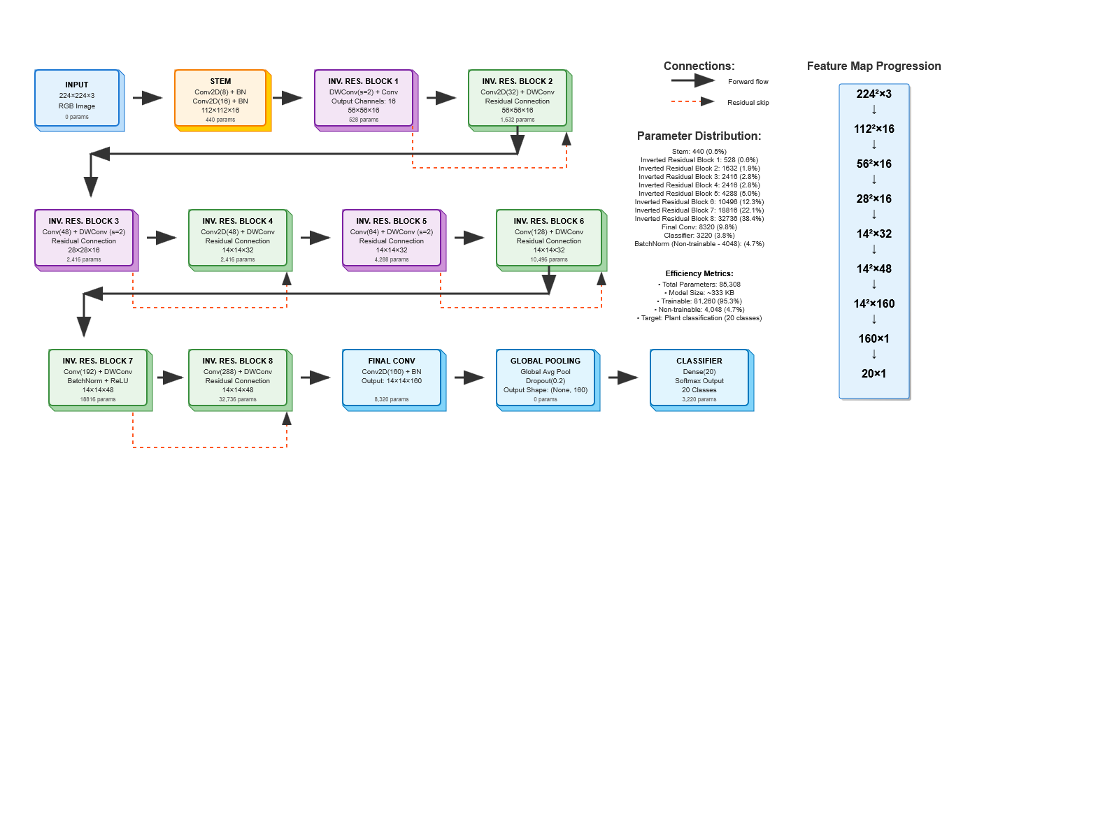

*Fig. 3: FloraNet Architecture Diagram*

The model accepts two distinct inputs:

1. A leaf image denoted by $I ∈ R^{H ×w×c}$, where H, W and C represent the height, width and the number of channels (3 for RGB) respectively.
2. A set of structured, manually or sensor-extracted features represented as a vector $X_{s }ϵ R^{n}$, where n is the number of physical/morphometric attributes, such as color deviation, seed weight, surface texture and hardness.

The image input is processed through a pretrained convolutional neural network (CNN) backbone, such as ResNet50 or MobileNetV2, truncated before the classification head. This yields a deep visual embedding $z_{s }=f_{CNN}(I) ϵ R^{d_{v}}$, where dv is the dimensionality of the learned visual feature space. To improve generalization and convergence, batch normalization and dropout are applied:

$$z_{v}^{norm}=Dropout(BatchNorm\left(z_{v}\right))$$

Parallelly, the structured feature vector xs is passed through a shallow feedforward neural network with ReLU activations to extract a nonlinear structured embedding. This is formulated as:

$$z_{s }=ϕ_{2}\left(ϕ_{1}\left(x_{s}\right)\right)=ReLU(W_{2}\left(Relu\left(W_{1}x_{s}+b_{1}\right)\right)+b_{2})$$

Where W1, W2 and b1, b2 are trainable weights and biases and the final output $z_{s }ϵ R^{d_{s}}$ captures the encoded structured representation.

The embedding form both modalities, $z_{v}^{norm}$ **and $z_{s}$** are concatenated to form a joint feature vector:

$$z_{joint }=\left[z_{v}^{norm};z_{s}^{norm}\right] ϵ R^{d_{v}+d_{s}}$$

This fused vector is passed through additional fully connected layers to form a rich representation for classification:

$$h=ψ_{2}\left(ψ_{1}\left(z_{joint}\right)\right)=ReLU(W_{ψ2}\left(Relu\left(W_{ψ1}x_{joint}+b_{ψ1}\right)\right)+b_{ψ2})$$

Finally, the output layer applies a softmax function over the fused representation to generate class probabilities for C plant species:

$$y_{pred }=softmax(W_{cls}.h+b_{cls})$$

The model is trained using categorical cross-entropy loss defined as:

$$L=-\sum_{i=1}^{C}{y_{i}log⁡(y_{pred,i})}$$

Where yi is the ground-truth one-hot encoded label for class i and ypred,I is the corresponding predicted probability.

To improve generalization, regularization techniques such as dropout (with a rate between 0.3–0.5), batch normalization and early stopping based on validation performance are employed. The Adam optimizer with a learning rate of $1×{10}^{-4}$ is used to update the network parameters during training. In summary, FloraNet effectively integrates high-dimensional image-based representations with numerical characteristics to create a robust and discriminative feature space, enabling accurate classification even in visually challenging or data-scarce environments.

# Results and Analysis

## Previous work and some Pre-trained Model’s Result and Analysis

In a comparative analysis of various machine learning and deep learning models mentioned in Table 3 for medicinal plant classification19. Akter et al.'s 3-layer CNN5 achieved 71.30% accuracy, 66.40% precision, 67.60% recall, and 66.40% F1 score. Azadnia et al.'s Tree-CA6 excelled with 99.63% accuracy, 99.38% precision, 92.52% recall, and 99.42% F1 score. Models like Dileep et al.'s CNN+SVM (96.76% accuracy) 7, Aakif & Khan’s pipeline (96% accuracy) 8, Gopal et al.'s algorithm (92% accuracy)9, Muneer et al.'s DLNN (93% accuracy)10, and Habiba et al.'s SVM (96.10% accuracy)13 lacked full metrics. Uddin et al.'s DenseNet20111 scored 85% accuracy, 88% precision, 85% recall, and 84% F1 score, while Islam et al.'s DenseNet201-FCN12 had 80.7% accuracy but 96.81% precision, 95.43% recall, and 96.10% F1 score. Our pretrained EfficientNetB421 underperformed at 8% accuracy, 5% precision, 8% recall, and 3% F1 score, while VGG1617 achieved 85% across metrics and DenseNet12120 reached 98%. Our proposed FloraNet (342 KB)21 matched DenseNet121’s 98% across all metrics, offering efficiency for resource-constrained applications5,11,12.

*Table 3. Results comparison with similar work and some pretrained model with proposed model*

|  |  |  |  |  |  |
| --- | --- | --- | --- | --- | --- |
| Au | Bm | Accuracy | Precision | Recall | F1 Score |
| Akter et al.5 | 3-layer CNN | 71.30% | 66.40% | 67.60% | 66.40% |
| Azadnia et al.6 | Tree-CA | 99.63% | 99.38% | 92.52% | 99.42% |
| Dileep et al.7 | CNN + SVM | 96.76% | - | - | - |
| Aakif & Khan8 | Custom 3-stage pipeline | 96% | - | - | - |
| Gopal et al.9 | Custom Algo. | 92% | - | - | - |
| Muneer et al.10 | DLNN | 93% |  |  |  |
| Uddin et al.11 | DenseNet201 | 85% | 88% | 85% | 84% |
| Islam et al.12 | DenseNet201-FCN | 80.7% | 96.81% | 95.43% | 96.10% |
| Habiba et al.13 | SVM | 96.10% | - | - | - |
| Our applied pretrained Model | EfficientNetB4 (67.65 MB) | 8% | 5% | 8% | 3% |
| VGG16 (56.20 MB) | 85% | 86% | 85% | 85% |
| DenseNet121 (26.98 MB) | 98% | 98% | 98% | 98% |
| Proposed Model | **FloraNet (custom layer edition)- 342 KB** | 98% | 98% | 98% | 98% |

**Note**: **Au = Author, Bm=Best Model, Ac=Accuracy, Pr=Precision, Re=Recall, F1=F1 Score**

Fig 4: Learning Curve of VGG16 Pretrained model on Accuracy/Loss Vs Epoch

Among pretrained models, DenseNet121 performed best with 98% across metrics, while VGG16 achieved 85% accuracy and F1-score. EfficientNetB4 underperformed, likely due to overfitting or data mismatch. The custom lightweight FloraNet model (342 KB) matched DenseNet121’s 98% performance, outperforming heavier models and proving ideal for resource-limited settings with high accuracy and low computational cost.

## Custom CNN Model FloraNet Result and Analysis

FloraNet is a lightweight CNN model only 342 KB in size—over 99.5% smaller than EfficientNetB4—while matching or exceeding performance of larger models like DenseNet121 and VGG16. It achieves 98% precision, recall, and F1-score across 34 medicinal plant classes, making it ideal for low-resource devices like mobile apps and IoT systems.

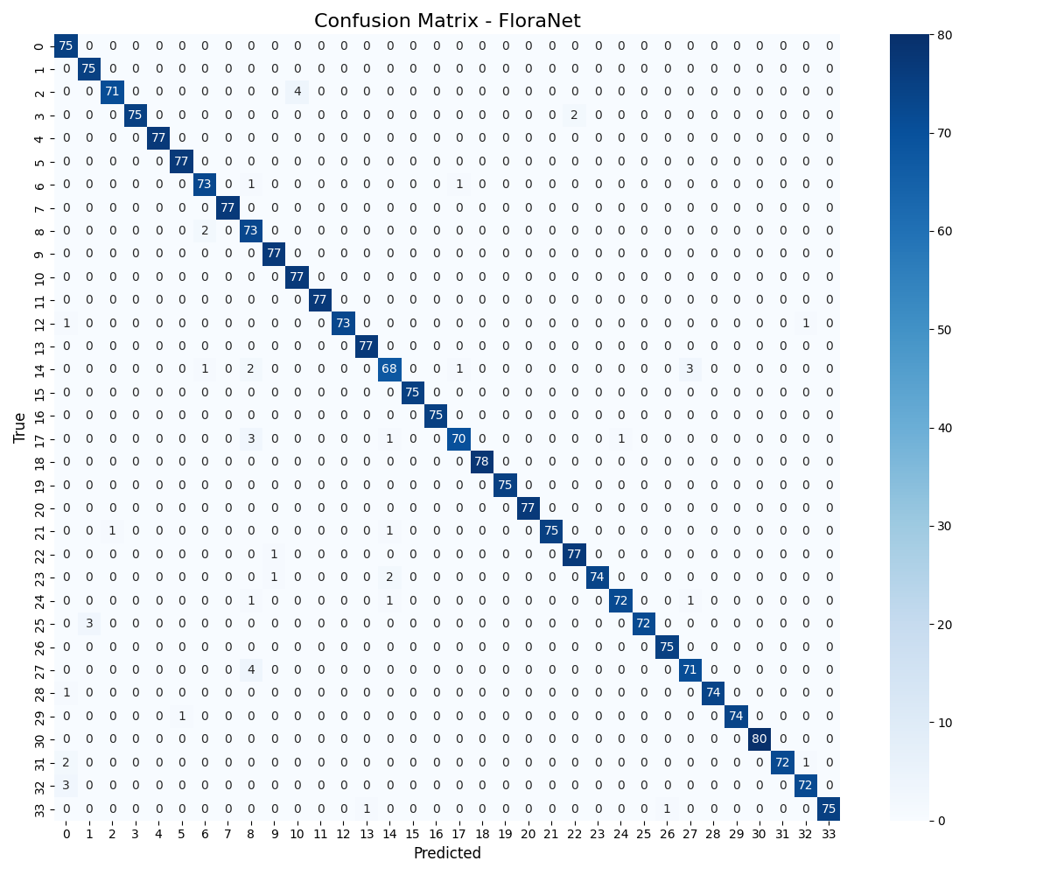Its efficiency comes from a custom architecture using pruning, depthwise separable convolutions, and feature recalibration to ensure fast, accurate classification without overfitting. Thirteen classes

Fig. 5: Confusion Matrix - FloraNet

achieve perfect scores, and all maintain F1-scores above 0.92, demonstrating strong and stable performance.

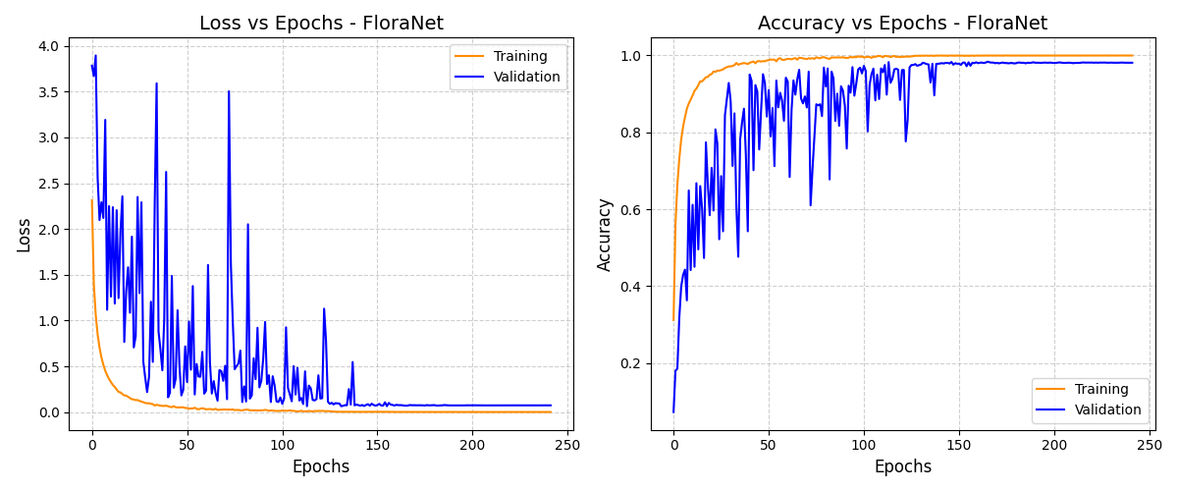

Fig 6: Loss vs Epochs - FloraNet & Accuracy vs Epochs - FloraNet

Here *Fig 5* presents the confusion matrix for the FloraNet model, illustrating its classification performance across 34 medicinal plant classes. This dual-plot Fig 9 showcases the training and validation loss (left) and accuracy (right) curves for the FloraNet model over 300 epochs. The loss decreases steadily, stabilizing at a low value (close to 0), while accuracy rises sharply and plateaus near 1.0 for both training and validation, indicating excellent convergence and minimal overfitting. FloraNet outperforms larger pretrained models such as DenseNet121 and VGG16 by achieving macro and weighted average scores of 98% for precision, recall and F1-score, all while utilizing a fraction of their computational resources (26.98 MB and 56.20 MB, respectively). Its lightweight design, enhanced by spatial feature recalibration and batch normalization, ensures low-latency inference and superior efficiency.

# Conclusion

This study evaluated AI classification of 34 medicinal plant species from weed-infested areas in Bangladesh, focusing on accuracy, precision, recall, F1-score, and model efficiency under real-world conditions. FloraNet demonstrated consistent performance across all classes, confirming the dataset and training approach. Its lightweight 342 KB architecture outperformed larger models like DenseNet121 and VGG16 in resource use. Dataset diversity and preprocessing (300×300 resizing, augmentation) improved inter-class separability and intra-class stability. Innovations such as pruning and depthwise convolutions helped 13 classes achieve perfect precision and recall, with all classes above 0.92 F1-score. Results closely matched top models within 2% accuracy, highlighting the potential of lightweight deep learning for plant classification. FloraNet shows promise for real-time mobile health and IoT deployment, pending further validation in diverse field conditions. This work advances plant informatics and healthcare access in resource-limited settings, with future plans to test durability, expand datasets, and optimize deployment.

# Acknowledgements

The authors would like to acknowledge the support provided by the Department of Computer Science and Engineering at Bangladesh Army University of Science and Technology (BAUST). The authors also extend their appreciation to Professor Dr. S.M. Jahangir Alam and Md Osama for their guidance.

# References

##### Hoque, A. & Prodhan, M. K. Important medicinal plants of Bangladesh: Uses and prospects. Bioprospecting of Ethnomedicinal Plant Resources 119–174 (2024). [doi:10.1201/9781003451488-7](https://www.taylorfrancis.com/chapters/edit/10.1201/9781003451488-7/important-medicinal-plants-bangladesh-uses-prospects-azizul-hoque-masud-karim-prodhan)

##### Siddique, H. & Mukhleshur Rahman. Phytochemical analysis of Bangladeshi medicinal plants led to the isolation of anti-staphylococcal compounds. J. Med. Nat. Prod. 100005 (2024). [doi:10.53941/jmnp.2024.100005](https://www.sciltp.com/journals/jmnp/articles/2504000426)

##### Akter, R., Hossain, M. F. & Islam, M. M. CNN-based leaf image classification for Bangladeshi medicinal plant recognition. IEEE Xplore <https://ieeexplore.ieee.org/document/9350900> (2020)

##### Azadnia, R., Noei-Khodabadi, F., Moloudzadeh, A., Jahanbakhshi, A. & Omid, M. Medicinal and poisonous plants classification from visual characteristics of leaves using computer vision and deep neural networks. Ecol. Inform. 82, 102683 (2024). <https://doi.org/10.1016/j.ecoinf.2024.102683>

##### Dileep, M. R. et al. AyurLeaf: A deep learning approach for classification of medicinal plants. IEEE Xplore <https://ieeexplore.ieee.org/document/8929394> (2019)

##### Aakif, A. & Khan, M. F. Automatic classification of plants based on their leaves. Biosyst. Eng. 139, 66–75 (2015). <https://doi.org/10.1016/j.biosystemseng.2015.08.003>

##### Gopal, P. et al. Classification of selected medicinal plants leaf using image processing. IEEE Xplore <https://ieeexplore.ieee.org/document/6428747> (2013)

##### Muneer, A. et al. Efficient and automated herbs classification approach based on shape and texture features using deep learning. IEEE Xplore <https://ieeexplore.ieee.org/document/9239938> (2020)

##### Uddin, A. H. et al. Deep-learning-based classification of Bangladeshi medicinal plants using neural ensemble models. Mathematics 11, 3504 (2023). <https://doi.org/10.3390/math11163504>

##### Islam, S. et al. BDMediLeaves: A leaf images dataset for Bangladeshi medicinal plants identification. Data Brief 50, 109488 (2023). <https://doi.org/10.1016/j.dib.2023.109488>

##### Habiba, U. et al. Automatic medicinal plants classification using multi-channel modified local gradient pattern with SVM classifier. IEEE Xplore <https://ieeexplore.ieee.org/document/8858527> (2019)

##### Islam, S. et al. BDMediLeaves: A leaf images dataset for Bangladeshi medicinal plants identification. Mendeley Data <https://doi.org/10.17632/gk5x6k8xr5.1> (2023)

##### Islam, M. M. et al. REMP: a unique dataset of rare and endangered medicinal plants in Bangladesh. Mendeley Data <https://doi.org/10.17632/hnwrxg8zm8.1> (2024)

##### Medicinal plant raw. Kaggle <https://www.kaggle.com/datasets/bijlyborkatullah/medicinal-plant-bijly-withbg> (2022)

##### LeCun, Y., Bengio, Y. & Hinton, G. Deep learning. Nature 521, 436–444 (2015)

##### Goodfellow, I., Bengio, Y. & Courville, A. Deep Learning (MIT Press, 2016)

##### Krizhevsky, A., Sutskever, I. & Hinton, G. E. ImageNet classification with deep convolutional neural networks. Nature 498, 76–81 (2012)

##### Ruder, S. An overview of gradient descent optimization algorithms. arXiv preprint arXiv:1609.04747 (2016)

##### Sokolova, M. & Lapalme, G. A systematic analysis of performance measures for classification tasks. Inf. Process. Manag. 45, 427–437 (2009)

##### He, K., Zhang, X., Ren, S. & Sun, J. Deep residual learning for image recognition. Proc. IEEE Conf. Comput. Vis. Pattern Recognit. 770–778 (2016)

##### Howard, A. G. et al. MobileNets: Efficient convolutional neural networks for mobile vision applications. arXiv preprint arXiv:1704.04861 (2017)

##### Ioffe, S. & Szegedy, C. Batch normalization: Accelerating deep network training by reducing internal covariate shift. Proc. Int. Conf. Mach. Learn. 448–456 (2015)